CHAPTER 1
INTRODUCTION
At present generation e-mail plays a prominent role. It is most used application for communication through which we can send text messages, documents, images and files. In present e-mail system we have only the facility of file sent notification. We don’t know whether receiver has seen it or not. To know whether mail send or not we proposed a system for message receipt facility.
  - existing System
In present e-mail system we have only the facility of file sent notification. But we don’t know whether receiver has seen it or not. Because of this some important mails may get ignored by the receiver after seeing it also.
Disadvantages
- We have only the facility of file sent notification.
- The sender doesn’t know whether user received the email or not.
- No acknowledgement

1.2 Proposed System

Our proposal system for message receipt facility when it is seen by the recipient, so that sender is aware of the fact that his message has been read. This also displays the time and date when the receiver opens the mail.

Advantages
- Sender is aware of the fact that his message has been read.
- This also displays the time and date when the receiver opens the mail.

1.3 motivation
- At present generation e-mail plays a prominent role. It is most used application for communication through which we can send text messages , documents , images and files. In present e-mail system we have only the facility of file sent notification.
1.4 Scope

Server supports remote access which enables senders, receivers and administrator can get the updates and send the notifications.

1.5 Outline
The following chapter would be Chapter 2, Literature Reviews which will describe the studies on existing systems, technologies needed and methodologies. Next would be Chapter 3, Requirement Specification which discusses about the functional and non-functional requirements. Following by Chapter 4, Design phase of the application which discusses about the required uml diagrams. Chapter 5 would be implementation details of the application, containing the sample code. Continue with Chapter 6, will be System Testing Details. Chapter 7 will be the Results of the execution and the next chapter would be Chapter 8 Conclusion and Future Scope followed by the bibliography.
CHAPTER 2

LITERATURE SURVEY
Literature survey is the most important step in software development process. Before developing the tool it is necessary to determine the time factor, economy n company strength. Once these things r satisfied, ten next steps are to determine which operating system and language can be used for developing the tool. Once the programmers start building the tool the programmers need lot of external support. This support can be obtained from senior programmers, from book or from websites. Before building the system the above consideration r taken into account for developing the proposed system.

One fundamental issue in today On-line Social Networks (OSNs) is to give users the ability to control the messages posted on their own private space to avoid that unwanted content is displayed. Up to now OSNs provide little support to this requirement. To fill the gap, in this paper, we propose a system allowing OSN users to have a direct control on the messages posted on their walls. This is achieved through a flexible rule-based system, that allows users to customize the filtering criteria to be applied to their walls, and a Machine Learning based soft classifier automatically labeling messages in support of content-based filtering.

CHAPTER 3
SOFTWARE REQUIREMENT SPECIFICATIONS

3.1 Introduction
A software requirements specification (SRS) is a description of a software system to be developed. It lays out functional and non-functional requirements, and may include a set of use cases that describe user interactions that the software must provide.
Software requirements specification establishes the basis for an agreement between customers and contractors or suppliers (in market-driven project, these roles may be played by the marketing and development divisions) on what the software product is to do as well as what it is not expected to do. Software requirements specification permits a rigorous assessment of requirements before design can begin and reduces later redesign. It should also provide a realistic basis for estimating product costs, risks, and schedules. Used appropriately, software requirements specifications can help prevent software project failure.

Purpose

The purpose of this document is to present a detailed description of the web application Mail Receive Authentication. It will explain the importance and features of the application, the interfaces of the application, what the application will do, the constraints under which it must operate.

Intended Audience and Reading Suggestions
This project is the college level project and is implementing under the guidance of college professors. This project is useful to administrators who handle cluster of systems. All the system are analyzed all at a time by using the evaluation mechanisms which are carried out using the DMS.
Mainly intended for organizations and colleges. Administrator who can review systems capabilities and more easily understand systems performance in a client server network

Product Scope
This application will be designed to overcome the drawbacks of the present email system. Specifically, the application is designed to communicate and to give the message receipt facility, so that sender is acknowledged with the message being read. The system also contains a relational database containing a list of users. The application will facilitate the acknowledgement about the mail being read by the receiver.

3.2 Overall Description

Product Perspective
The mail receive authentication system will be a new web based system. It will be implemented on client/server model network.
Product Function
This has an easy to use main menu, from which the rest of the features or functions can be accessed. These main features as listed are: account login, composing mail, checking sent mails and logout.

User Classes and Characteristics

Our application hopes to draw on two main user groups. The users and admin have individual login id and password. The two main user groups are sender and receiver.

1. User:

User can be a sender or receiver. Both the users must register and the login to send or receive mail. The sender sends the mail to the receiver. The receiver receives it and the acknowledgement is send to the sender.

2. Admin:

The admin can directly login into his account and he can view the users and delete the users.

Operating Environment

Software Requirements

Technology : Java

Tool : NetBeans 8.1

Operating System : Windows 2000 server Family or higher version

Techniques : JDK 1.5

Data Base : Oracle10g

Hardware Requirements

Processor : Pentium-III (or) Higher

RAM : 64MB (or) Higher

Cache : 512MB

Hard disk : More than 10GB

3.3 External Interface Requirements
Login Screen This is for the Administrator to get into the application.
Admin Account This shows the all the information of all the systems.
New Registrations This activity or utility is to register new users or clients in the server.
3.4 Functional Requirements
Modules
1. USER:
User can be a sender or receiver. Both the users must register and the login to send or receive mail. The sender sends the mail to the receiver. The receiver receives it and the acknowledgement is send to the sender.
2. ADMIN:
The admin can directly login into his account and he can view the users and delete the users.
USER LOGIN:
The user provides the username and password. After the authentication, he gets access to the mail.
SENDING MAIL:
The composed mail is sent to the receiver by providing the receiver email address.
RECEIVING MAIL:
The receiver receives the mail from the sender.
ACKNOWLEDGMENT:
The sender acknowledged about the message being read.
3.5 Non-Functional Requirements
Performance Requirements
Performance is measured in terms of the output provided by the application. It is very difficult to change the system once it has been designed and on the other hand designing a system, which does not cater to the requirements of the user, is of no use. The requirement specification for any system can be broadly stated as given below:
- The system should be able to interface with the existing system.
- The system should be accurate.
- The system should be better than the existing system.

CHAPTER 4
SYSTEM DESIGN

4.1 Importance Of Design
The purpose of the design phase is to plan a solution of the problem specified by the requirement document. This phase is the first step in moving from the problem domain to the solution domain. In other words, starting with what is needed, design takes us toward how to satisfy the needs. The design of a system is perhaps the most critical factor affection the quality of the software; it has a major impact on the later phase, particularly testing, maintenance. The output of this phase is the design document. This document is similar to a blueprint for the solution and is used later during implementation, testing and maintenance. The design activity is often divided into two separate phases System Design and Detailed Design.
System Design also called top-level design aims to identify the modules that should be in the system, the specifications of these modules, and how they interact with each other to produce the desired results. During, Detailed Design, the internal logic of each of the modules specified in system design is decided. During this phase, the details of the data of a module is usually specified in a high-level design description language, which is independent of the target language in which the software will eventually be implemented.
In system design the focus is on identifying the modules, whereas during detailed design the focus is on designing the logic for each of the modules During the system design activities, Developers bridge the gap between the requirements specification, produced during requirements elicitation and analysis, and the system that is delivered to the user.

UML Diagrams
The unified Modeling Language (UML) is a standard language for writing software blueprints. The UML may be used to visualize, specify, construct and document the artifacts of software-intensive system.
Use Case Diagrams
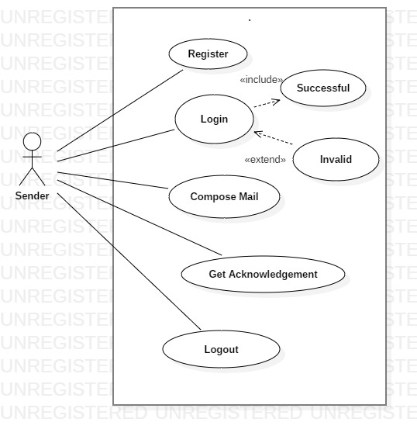
Use Case Diagram For Sender
The sender interfaces with the application. The application here is mail receive authentication system. To interface with the application sender has to enter the username and password. After logging in, the sender can compose mail and get the acknowledgement.
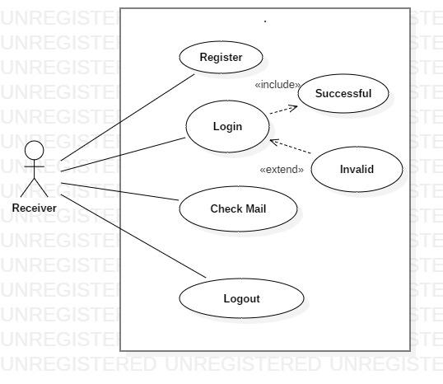
Use Case Diagram For Receiver
The receiver interfaces with the application. The application here is mail receive authentication system. To interface with the application receiver has to enter the username and password. After logging in, the receiver can check the mails.
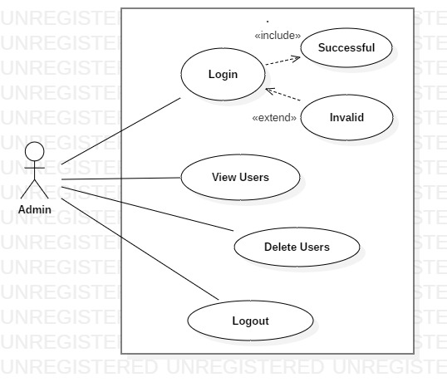

Use Case Diagram For Admin :
The Admin interfaces with the application. To interface with the application admin has to enter the username and password. After logging in, the admin can view or delete users.

Class Diagram:
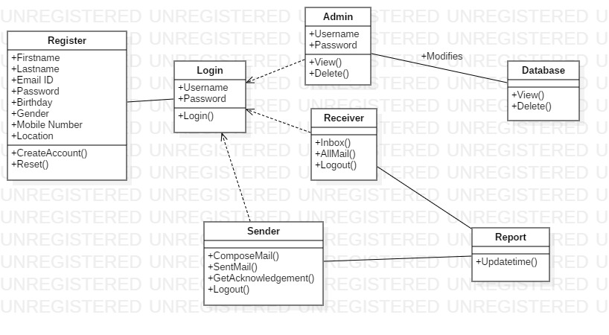

The class diagram above shows a hierarchy – a series of classes and their subclasses. The first class is Register class which has attributes as first name, last name, email, password, birthday, gender, mobile number and location. The operations are creating an account and reset. Using association relationship, it is connected to login class, where we have a common attribute: username and password. The operations are login. Using dependency relationship three more classes named Sender, Receiver and Admin are connected to the login class. The admin class has view and delete operations. Using association relationship, it is connected to the Database class. The Receiver class has inbox, all mail and logout operations. The Sender class has compose mail, sent mail, get acknowledgement and logout operations. They both are connected to report class by association relationship.

Sequence Diagram:

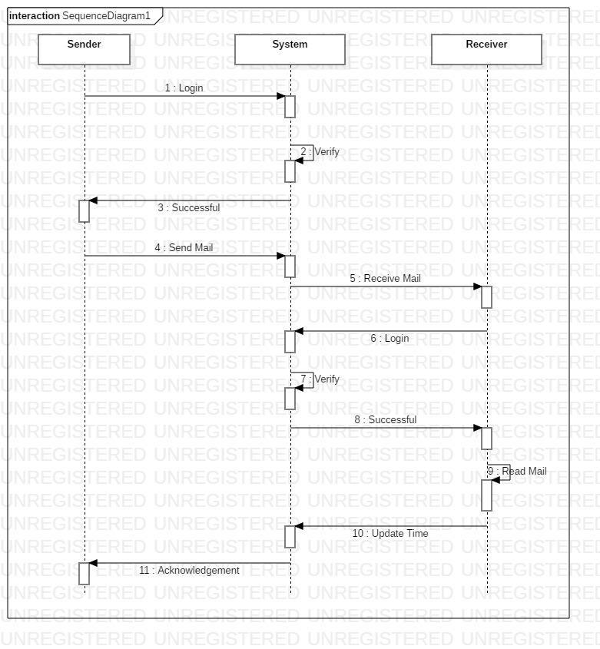

The figure above shows a sequence diagram that specifies the flow of control involved in authenticating users and displaying the details. At this level of abstraction, the objects involved are: sender, receiver and admin. The sequence begins with the logging in, sending and receiving mails, getting acknowledgement and logout.

Activity Diagram :

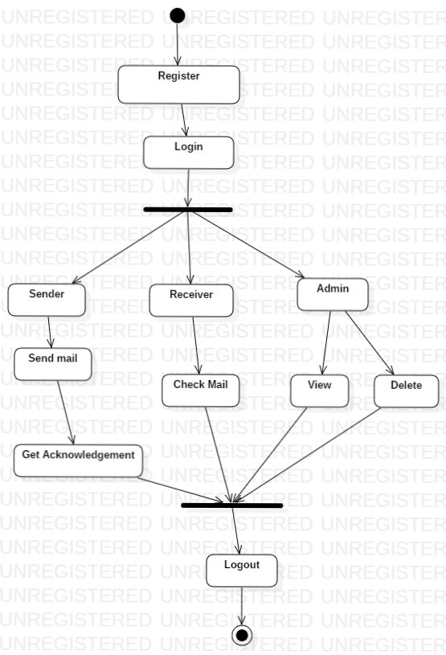

The activity diagram starts from register, logging in, sending or checking mails, view or delete users, getting acknowledgement and ends with logging out.

CHAPTER 5
IMPLEMENTATION
Implementation includes all those activities that take place to convert from the old system to the new. The old system consists of manual operations, which is operated in a very different manner from the proposed new system. A proper implementation is essential to provide a reliable system to meet the requirements of the organizations. An improper installation may affect the success of the computerized system.
5.1 Sample Code

// home page
<!DOCTYPE html>
<html lang="en">
<head>
<meta charset="utf-8">
<meta http-equiv="X-UA-Compatible" content="IE=edge">
<meta name="viewport" content="width=device-width, initial-scale=1.0">
<meta name="description" content="">
<meta name="author" content="">
<link rel="shortcut icon" href="../../docs-assets/ico/favicon.png">

<title>Mail Received Authentication System</title>

<!-- Bootstrap core CSS -->
<link href="assets/css/bootstrap.css" rel="stylesheet">

<!-- Custom styles for this template -->
<link href="assets/css/main.css" rel="stylesheet">

<script src="https://code.jquery.com/jquery-1.10.2.min.js"></script>
<script src="assets/js/hover.zoom.js"></script>
<script src="assets/js/hover.zoom.conf.js"></script>

<!-- HTML5 shim and Respond.js IE8 support of HTML5 elements and media queries -->
<!--[if lt IE 9]>
<script src="https://oss.maxcdn.com/libs/html5shiv/3.7.0/html5shiv.js"></script>
<script src="https://oss.maxcdn.com/libs/respond.js/1.3.0/respond.min.js"></script>
<![endif]-->
</head>

<body>

<!-- Static navbar -->
<div class="navbar navbar-inverse navbar-static-top">
<div class="container">
<div class="navbar-header">
<button type="button" class="navbar-toggle" data-toggle="collapse" data-target=".navbar-collapse">
<span class="icon-bar"></span>
<span class="icon-bar"></span>
<span class="icon-bar"></span>
</button>
<a class="navbar-brand" href="index.html">Mail Received Authentication System</a>
</div>
<div class="navbar-collapse collapse">
<ul class="nav navbar-nav navbar-right">
<li><a href="index.html">HOME</a></li>
<li><a href="newaccount.jsp">CREATE ACCOUNT</a></li>
<li><a href="accountlogin.jsp">LOGIN</a></li>
<li><a href="adminaccount.jsp">ADMIN</a></li>
</ul>
</div><!--/.nav-collapse -->
</div>
</div>

<!-- +++++ Welcome Section +++++ -->
<div id="ww">
<div class="container">
<div class="row">
<div class="col-lg-8 col-lg-offset-2 centered">
<img src="assets/img/user.png" alt="Stanley">
<h1>Hi, I am Something!</h1>

<p style=" font-size: 24px; text-align: justify;
padding-top: 5px;
/*padding-bottom: 600px;*/
font-style:italic;
margin-bottom:30px;
margin-left: 15px;
margin-right: 15px;
color: black;
line-height: 40px;

/* font-weight: 500px;*/

/* border-bottom:1px dashed #00CA79;*/
font-family:Times New Roman ; ">At present generation e-mail plays a prominent role. It is most used application for communication through which we can send text messages , documents , images and files. In present e-mail system we have only the facility of file sent notification.In present e-mail system we have only the facility of file sent notification. But we don’t know whether receiver has seen it or not.Our proposal system for message receipt facility when it is seen by the recipient ,so that sender is aware of the fact that his message has been read. This also displays the time and date when the receiver opens the mail.

</font>
</p>
</div><!-- /col-lg-8 -->
</div><!-- /row -->
</div> <!-- /container -->
</div><!-- /ww -->

<script src="assets/js/bootstrap.min.js"></script>
</body>
</html>

// Accountlogin.jsp
<%--
Document : newaccount
Created on : Jun 22, 2017, 10:38:47 AM
Author : VENKAT
--%>
<%String msg=request.getParameter("msg");%>
<%@page contentType="text/html" pageEncoding="UTF-8"%>
<!DOCTYPE html>
<html lang="en">
<head>
<meta charset="utf-8">
<meta http-equiv="X-UA-Compatible" content="IE=edge">
<meta name="viewport" content="width=device-width, initial-scale=1.0">
<meta name="description" content="">
<meta name="author" content="">
<link rel="shortcut icon" href="../../docs-assets/ico/favicon.png">

<title>Mail Received Authentication System</title>

<!-- Bootstrap core CSS -->
<link href="assets/css/bootstrap.css" rel="stylesheet">

<!-- Custom styles for this template -->
<link href="assets/css/main.css" rel="stylesheet">

<script src="https://code.jquery.com/jquery-1.10.2.min.js"></script>
<script src="assets/js/hover.zoom.js"></script>
<script src="assets/js/hover.zoom.conf.js"></script>

<script type="text/javascript">

function validate()
{

var c=document.reg.email.value;
var d=document.reg.password.value;

if (c.indexOf("@gmail", 0) < 0)
{
alert("Please enter a valid e-mail address. Like @gmail");
document.reg.email.focus();
return false;
}
if (c.indexOf(".", 0) < 0)
{
alert("Please enter a valid e-mail address.");
document.reg.email.focus();
return false;
}
return true;
}
</script>
</head>

<body>

<!-- Static navbar -->
<div class="navbar navbar-inverse navbar-static-top">
<div class="container">
<div class="navbar-header">
<button type="button" class="navbar-toggle" data-toggle="collapse" data-target=".navbar-collapse">
<span class="icon-bar"></span>
<span class="icon-bar"></span>
<span class="icon-bar"></span>
</button>
<a class="navbar-brand" href="index.html">Mail Received Authentication System</a>
</div>
<div class="navbar-collapse collapse">
<ul class="nav navbar-nav navbar-right">
<li><a href="index.html">HOME</a></li>
<li><a href="newaccount.jsp">CREATE ACCOUNT</a></li>
<li><a href="accountlogin.jsp">LOGIN</a></li>
<li><a href="adminaccount.jsp">ADMIN</a></li>
</ul>
</div><!--/.nav-collapse -->
</div>
</div>

<!-- +++++ Welcome Section +++++ -->
<div id="ww">
<div class="container">
<div class="row">

<div class="col-lg-8 col-lg-offset-2 centered">
<%if(msg!=null){%>
<h1><font color="green"><%=msg%></font></h1>
<%}%>
<h2> Account Login Here </h2>
<form name="reg" action="accountlogin1.jsp" method="post" onsubmit="return validate()">
<br>
<table align="center" cellpadding="10" border="10" >

<tr><td>Email-ID</td><td><input type="text" name="email"required placeholder="Choose Mail Id "></td></tr>
<tr><td>Choose Password</td><td><input type="password" name="password"required placeholder="Choose Password"></td></tr>

<tr><td><input type="Submit" value="Login "></td><td><input type="Reset" value="Reset"></td></tr>

</table>
</form>
</div><!-- /col-lg-8 -->
</div><!-- /row -->
</div> <!-- /container -->
</div><!-- /ww --

<script src="assets/js/bootstrap.min.js"></script>
</body>
</html>
<%--
Document : useraccount
Created on : Jun 22, 2017, 12:00:58 PM
Author : VENKAT
--%>

<%@page contentType="text/html" pageEncoding="UTF-8"%>
<% String email=(String)session.getAttribute("email");%>
<!DOCTYPE html>
<html lang="en">
<head>
<meta charset="utf-8">
<meta http-equiv="X-UA-Compatible" content="IE=edge">
<meta name="viewport" content="width=device-width, initial-scale=1.0">
<meta name="description" content="">
<meta name="author" content="">
<link rel="shortcut icon" href="../../docs-assets/ico/favicon.png">

<title>Mail Received Authentication System</title>

<!-- Bootstrap core CSS -->
<link href="assets/css/bootstrap.css" rel="stylesheet">

<!-- Custom styles for this template -->
<link href="assets/css/main.css" rel="stylesheet">

<script src="https://code.jquery.com/jquery-1.10.2.min.js"></script>
<script src="assets/js/hover.zoom.js"></script>
<script src="assets/js/hover.zoom.conf.js"></script>

<!-- HTML5 shim and Respond.js IE8 support of HTML5 elements and media queries -->
<!--[if lt IE 9]>
<script src="https://oss.maxcdn.com/libs/html5shiv/3.7.0/html5shiv.js"></script>
<script src="https://oss.maxcdn.com/libs/respond.js/1.3.0/respond.min.js"></script>
<![endif]-->
</head>

<body>

<!-- Static navbar -->
<div class="navbar navbar-inverse navbar-static-top">
<div class="container">
<div class="navbar-header">
<button type="button" class="navbar-toggle" data-toggle="collapse" data-target=".navbar-collapse">
<span class="icon-bar"></span>
<span class="icon-bar"></span>
<span class="icon-bar"></span>
</button>
<a class="navbar-brand" href="index.html">Mail Received Authentication System</a>
</div>
<div class="navbar-collapse collapse">

<ul class="nav navbar-nav navbar-right">

<li><a href="adminhome.jsp">HOME</a></li>
<li><a href="viewusers.jsp">VIEW USERS</a></li>
<li><a href="deleteusers.jsp">DELETE USERS</a></li>

<li><a href="index.html">LOGOUT</a></li>
</ul>
</div><!--/.nav-collapse -->
</div>
</div>

<!-- +++++ Welcome Section +++++ -->
<div id="ww">
<div class="container">
<CENTER><img src="assets/img/user.png" alt="Stanley"></center>
<CENTER><h1>Hi &nbsp;<font color="blue" size="8"><%=email%></FONT></h1></CENTER>

<div class="row">
<div class="col-lg-8 col-lg-offset-2 centered">

<p></p>
</div><!-- /col-lg-8 -->
</div><!-- /row -->
</div> <!-- /container -->
</div><!-- /ww -->

<script src="assets/js/bootstrap.min.js"></script>
</body>
</html>
// create account.jsp
<%--
Document : createaccount
Created on : Jun 22, 2017, 11:28:37 AM
Author : VENKAT
--%>

<%@page contentType="text/html" pageEncoding="UTF-8"%>

<%@page import="java.sql.*"%>
<%
String fname=request.getParameter("fname");
String lname=request.getParameter("lname");
String email=request.getParameter("email");
String password=request.getParameter("password");
String cpassword=request.getParameter("cpassword");
String birthday=request.getParameter("birthday");
String gender=request.getParameter("gender");
String mobile=request.getParameter("mobile");
String location=request.getParameter("location");
int count=0;
try
{
Class.forName("com.mysql.jdbc.Driver");
Connection con=DriverManager.getConnection("jdbc:mysql://localhost:3306/email","root","root");
Statement st=con.createStatement();
ResultSet rs=st.executeQuery("select count(*) from newaccount where email='"+email+"'");
if(rs.next())
{
count=rs.getInt(1);
if(count==0)
{
int i=st.executeUpdate("insert into newaccount values('"+fname+"','"+lname+"','"+email+"','"+password+"','"+cpassword+"','"+birthday+"','"+gender+"','"+mobile+"','"+location+"',now())");

if(i==0)
{
response.sendRedirect("newaccount.jsp?msg=failure");
}
else
{
response.sendRedirect("newaccount.jsp?msg=Account Created Suceesfully");
}
}
else
{
response.sendRedirect("newaccount.jsp?msg=User Already Exists For This email-Id");
}
}
}
catch(Exception e)
{
out.println(e);
}
%>
5.2 Methodologies
INTRODUCTION TO JAVA

About Java:

Initially the language was called as “oak” but it was renamed as “java” in 1995.The primary motivation of this language was the need for a platform-independent(i.e. architecture neutral)language that could be used to create software to be embedded in various consumer electronic devices.
- Java is a programmer’s language
- Java is cohesive and consistent
- Except for those constraint imposed by the Internet environment. Java gives the programmer, full control

Finally Java is to Internet Programming where c was to System Programming.
Importance of Java to the Internet

Java has had a profound effect on the Internet. This is because; java expands the Universe of objects that can move about freely in Cyberspace. In a network, two categories of objects are transmitted between the server and the personal computer. They are passive information and Dynamic active programs. in the areas of Security and probability. But Java addresses these concerns and by doing so, has opened the door to an exciting new form of program called the Applet.

Applications and applets.

An application is a program that runs on our Computer under the operating system of that computer. It is more or less like one creating using C or C++ .Java’s ability to create Applets makes it important. An Applet I san application, designed to be transmitted over the Internet and executed by a Java-compatible web browser. An applet I actually a tiny Java program, dynamically downloaded across the network, just like an image. But the difference is, it is an intelligent program, not just a media file. It can be react to the user input and dynamically change.

Java Architecture
Java architecture provides a portable, robust, high performing environment for development. Java provides portability by compiling the byte codes for the Java Virtual Machine, which is then interpreted on each platform by the run-time environment. Java is a dynamic system, able to load code when needed from a machine in the same room or across the planet.

Compilation of code

When you compile the code, the Java compiler creates machine code (called byte code)for a hypothetical machine called Java Virtual Machine(JVM). The JVM is supposed t executed the byte code. The JVM is created for the overcoming the issue of probability. The code is written and compiled for one machine and interpreted on all machines .This machine is called Java Virtual Machine.
Compiling and interpreting java source code.

Source code
Pc compiler
Macintosh compiler
SPARC Compiler
Java Byte code

Platform independent
Java interpreter
Java interpretermacintosh

)))

Java interpreter(SPARC)
During run-time the Java interpreter tricks the byte code file into thinking that it is running on a Java Virtual Machine. In reality this could be an Intel Pentium windows 95 or sun SPARCstation running Solaris or Apple Macintosh running system and all could receive code from any computer through internet and run the Applets.
Simple:
Java was designed to be easy for the Professional programmer to learn and to use effectively. If you are an experienced C++ Programmer. Learning Java will oriented features of C++ . Most of the confusing concepts from C++ are either left out of Java or implemented in a cleaner, more approachable manner. In Java there are a small number of clearly defined ways to accomplish a given task.

Object oriented
Java was not designed to be source-code compatible with any other language. This allowed the Java team the freedom to design with a blank state. One outcome of this was a clean usable, pragmatic approach to objects. The object model in Java is simple and easy to extend, while simple types, such as integers, are kept as high-performance non-objects.

Robust
The multi-platform environment of the web places extraordinary demands on a program, because the program must execute reliably in a variety of systems. The ability to create robust programs. Was given a high priority in the design of Java. Java is strictly typed language; it checks your code at compile time and runtime.
Java virtually eliminates the problems of memory management and deal location, which is completely automatic. In a well-written Java program, all run-time errors can and should be managed by your program.

    - Servlets/JSP

INTRODUCTION

A Servlet Is a generic server extension. a Java class that can be loaded
Dynamically to expand the functionality of a server.Servlets are commonly used with web servers. Where they can take the place CGI scripts.

A servlet is similar to proprietary server extension, except that it runs inside a Java Virtual Machine (JVM) on the server, so it is safe and portable

Servlets operate solely within the domain of the server.

Unlike CGI and Fast CGI, which use multiple processes to handle separate program or separate requests, separate threads within web server process handle all servlets. This means that servlets are all efficient and scalable.

Servlets are portable; both across operating systems and also across web servers. Java Servlets offer the best possible platform for web application development.

Servlets are used as replacement for CGI scripts on a web server, they can extend any sort of server such as a mail server that allows servelts t extend its functionality perhaps by performing a virus scan on all attached documents or handling mail filtering tasks.

Servlets provide a Java-based solution used to address the problems currently associated with doing server-side programming including inextensible scripting solutions platform-specific API’s and incomplete interface.

Servlets are objects that conform to a specific interface that can be plugged into a Java-based server.Servlets are to the server-side what applets are to the server-side what applets are to the client-side-object byte codes that can be dynamically loaded off the net. They differ form applets in than they are faceless objects(with out graphics or a GUI component).They serve as platform independent, dynamically loadable,plugable helper byte code objects on the server side that can be used to dynamically extend server-side functionality.

For example an HTTP servlet can be used to generate dynamic HTML content when you use servlets to do dynamic content you get the following advantages:

- They’re faster and cleaner then CGI scripts
- They use a standard API( the servlet API)
- They provide all the advantages of Java (run on a variety of servers without needing to be rewritten)

A t t r a c t i v e n e s s o f S e r v l e t s:
They are many features of servlets that make them easy and attractive to tuse these include:
- Easily configure using the GUI-based Admin tool]
- Can be Loaded and Invoked from a local disk or remotely across the network.
- Can be linked together or chained, so that on servlet can call another servlet, or several servlets in sequence.
- Can be called dynamically from with in HTML, pages using server-side include-tags.
- Are secure-even when downloading across the network, the servlet security model and servlet and box protect your system from unfriendly behavior.,
Advantages of the servlet API

One of the great advantages of the servlet API is protocol independent. It assumes nothing about:
- The protocol being used to transmit on the net
- How it is loaded
- The server environment it will be running in
- These quantities are important, because it allows the Servlet API to be embedded in many different kinds of servers. There are other advantages to the servelt API as well These include:
- It’s extensible-you can inherit all your functionality from the base classes made available to you
- It’s simple small, and easy to use.
Features of Servlets:

- Servlets are persistent.Servlet are loaded only by the web server and can maintain services between requests.
- Servlets are fast. Since servlets only need to be l\loaded once, they offer much better performance over their CGI counterparts.
- Servlets are platform independent.
- Servlets are extensible Java is a robust, object-oriented programming language, which easily can be extended to suit your needs.
- Servlets are secure
- Servlets are used with a variety of client.

Servlets are classes and interfaces from tow packages,javax .servlet and javax.servlet.http.The java.servlet package contains classes t support generic, protocol-independent servlets.The classes in the javax.servelt.http package To and HTTP specific functionality extend these classes

Every servlet must implement the javax.servelt interface.Most servlets implement it by extending one of two classes.javax.servlet.GenericServlet or javax.servlet.http.HttpServlet.A protocol-independent servlet should subclass Generic-Servlet.while an Http servlet should subclass HttpServlet, which is itself a subclass of Generic-servlet with added HTTP-specific functionality.

Unlike a java program, a servlet does not have a main() method,Instead the server in the process of handling requests invoke certain methods of a servlet.Each time the server dispatches a request to a servlet, it invokes the servelts Service() method,

A generic servlet should override its service() method to handle requests as appropriate for the servlet.The service() accepts two parameters a request object and a response object .The request object tells the servlet about the request, while the response object is used to return a response

InContrast.anHttp servlet usually does not override the service() method.Instead it overrides doGet() to handle GET requests and doPost() to handle Post requests. An Http servlet can override either or both of these modules the service() method of HttpServlet handles the setup and dispatching to all the doXXX() methods.which iswhy it usually should not be overridden

The remainders in the javax.servlet and javax.servlet.http.package are largely support classes .The ServletRequest and ServletResponse classes in javax.servlet provide access to generic server requests and responses while HttpServletRequest and HttpServletResponse classes in javax.servlet provide access to generic server requests and responses while HttpServletRequest and HttpServletResponse in javax.servlet.http provide access a HTTP requests and responses . The javax.servlet.http provide contains an HttpSession class that provides built-in session tracking functionality and Cookie class that allows quickly setup and processing HttpCookies.
Loading Servlets:
Servlets can be loaded from their places. From a directory that is on the CLASSPATH. The CLASSPATH of the JavaWebServer includes service root/classes/, which is where the system classes reside

From the <SERVICE_ROOT/servlets/directory.This is not in the server’s classpath. A class loader is used to create servlets form this directory.New servlets can be added-existing servlets can be recompiled and the server will notice these changes. From a remote location.For this a code base like http://nine.eng/classes/foo/ is required in addtion to the servlet’s class name.Refer to the admin Gui docs on servlet section to see how to set this up.

Loading Remote Servlets
Remote servlets can be loaded by:

- Configuring the admin Tool to setup automatic loading of remote servlets.
- Selectiong up server side include tags in .html files
- Defining a filter chain Configuration
Invoking Servlets

A servlet invoker is a servlet that invokes the “server” method on a named servlet.If the servlet is not loaded in the server,then the invoker first loades the servlet(either form local disk or from the network) and the then invokes the “service” method.Also like applets,local servlets in the server can be identified by just the class name.In other words, if a servlet name is not absolute.it is treated as local.

A Client can Invoke Servlets in the Following Ways:
- The client can ask for a document that is served by the servlet.
- The client(browser) can invoke the servlet directly using a URL, once it has been mapped using the SERVLET ALIASES Section of the admin GUI
- The servlet can be invoked through server side include tags.
- The servlet can be invoked by placing it in the servlets/directory
- The servlet can be invoked by using it in a filter chain
The Servlet Life Cycle:-

The Servlet life cycle is one of the most exciting features of Servlets.This life cycle is a powerful hybrid of the life cycles used in CGI programming and lower-level NSAPI and ISAPI programming.

The servlet life cycle allows servlet engines to address both the performance and resource problems of CGI and the security concents of low level server API programming.

Servlet life cycle is highly flexible Servers hava significant leeway in how they choose to support servlets.The only hard and fast rule is that a servlet engine must confor to the following life cycle contact:

- Create and initialize the servlets
- Handle zero or more service from clients
- Destroy the servlet and then garbage Collects it.

It’s perfectly legal for a servlet t be loaded, created an initialzed in its own JVM,only to be destroyed an dgarbage collected without hancdling any clientrequest or after handling just one request

The most common and most sensible life cycle implemntations for HTTP servelts are:

Single java virtual machine and astatine persistence.

Init and Destroy:-

Just like Applets servlets can define init() and destroy() methods, A servlets init(ServiceConfig) method is called by the server immediately after the server constructs the servlet’s instance.Depanding on the server and its configuration, this can be at any of these times

- When the server states
- When the servlet is first requested, just before the service() method is invoked
- At the request of the server administrator

In any case, nit() is guaranteed to be called before the servlet handles its first request

The init() method is typically used to perform servlet initialization creating or loading objects that are used by the servlet in handling of its request. In order to providing a new servlet any information about itself and its environment, a server has to call a servelts init() method and pass an object that implement the ServletConfig interface.

This ServletConfig object supplies a servlet with information about its initialization parameters.These parameters are given to the servlets and are not associated with any single request.They can specify initial values, such as where a counter should begin counting, or default values, perhaps a template to use when not specified by the request,

The server calls a servlet’s destroy() method when the servlet is about to be unloaded. In the destroy() method, a servlet should free any resources it has acquired that will not be garbage collected. The destroy() method also gives a servlet a chance to write out its unsaved. cached information or any persistent information that should be read during the next call to init().
Session Tracking:
HTTP is a stateless protocol, it provides no way for a server to recognize that a sequence of requests is all from the same client. This causes a problem for application such as shopping cart applications. Even in chat application server can’t know exactly who’s making a request of several clients.

The solution for this is for client to introduce itself as it makes each request, Each clients needs to provide a unique identifier that lets the server identify it, or it needs to give some information that the server can use to properly handle the request, There are several ways to send this introductory information with each request Such as:
USER AUTHORIZATION:

One way to perform session tracking is to leverage the information that comes with
User authorization. When a web server restricts access to some of its resources to only those clients that log in using a recognized username and password. After the client logs in, the username is available to a servlet through getRemoteUser ()

Wean use the username to track the session. Once a user has logged in, the browser remembers her username and resends the name and password as the user views new pages on the site. A servlet can identify the user through her username and they’re by
Track her session.

The biggest advantage of using user authorization to perform session tracking is that it’s easy to implement. Simply tell the protect a set of pages, and use getRemoteUser() to identify each client.Another advantage is that the technique works even when the user accesses your site form or exists her browser before coming back.

The biggest disadvantage of user authrization is that it requires each user to register for an account and then log in in each time the starts visiting your site. Most users will tolerate registering and lagging in as a necessary evil when they are accessing sensitive information, but its all overkill for simple session tracking.Other problem with user authorization is that a user cannot simultaneously maintain more than one session at the same site.
Hidden Form Fields:
One way to support anonymous session tracking is to use hidden from fields. As the name implies, these are fields added to an HTML, form that are not displayed in the client’s browser, They are sent back to the server when the form that contains them is submitted.
In a sense, hidden form fields define constant variables for a form. To a servlet receiving a submitted form, there is no difference between a hidden fields and a visible filed.
As more and more information is associated with a clients session . It can become burdensome to pass it all using hidden form fields. In these situations it’s possible to pass on just a unique session ID that identifies as particular clients session.
That session ID can be associated with complete information about its session that is stored on the server.
The advantage of hidden form fields is their ubiquity and support for anonymity. Hidden fields are supported in all the popular browsers, they demand on special server requirements, and they can be used with clients that haven’t registered or logged in.
The major disadvantage with this technique, however is that works only for a sequence of dynamically generated forms, The technique breaks down immediately with static documents, emailed documents book marked documents and browser shutdowns.
URL Rewriting:
URL rewriting is another way to support anonymous session tracking, With URL rewriting every local URL the user might click on is dynamically modified. or rewritten, to include extra, information. The extra information can be in the deform of extra path information, added parameters, or some custom, server-specific.URL change. Due to the limited space available in rewriting a URL, the extra information is usually limited to a unique session.
Each rewriting technique has its own advantage and disadvantage
Using extra path information works on all servers, and it works as a target for forms that use both the Get and Post methods. It does not work well if the servlet has to use the extra path information as true path information
The advantages and disadvantages of URL.rewriting closely match those of hidden form fileds,The major difference is that URL rewriting works for all dynamically created documents, such as the Help servlet, not just forms. With the right server support, custom URL rewriting can even work for static documents.
Persistent Cookies:
A fourth technique to perform session tracking involves persistent cookies. A cookie is a bit of information. sent by a web server to a browser that can later be read back form that browser. When a browser receives a cookie, it saves the cookie and there after sends the cookie back to the server each time it accesses a page on that server, subject to certain rules. Because a cookie’s value can uniquely identify a client, cookies are often used for session tracking.

Persistent cookies offer an elegant, efficient easy way to implement session tracking. Cookies provide as automatic an introduction for each request as we could hope for. For each request, a cookie can automatically provide a client’s session ID or perhaps a list of clients performance. The ability to customize cookies gives them extra power and versatility.
The biggest problem with cookies is that browsers don’t always accept cookies sometimes this is because the browser doesn’t support cookies. More often its because
The browser doesn’t support cookies. More often its because the user has specifically configured the browser to refuse cookies.
The power of serves:
The power of servlets is nothing but the advantages of servlets over other approaches, which include portability, power, efficiency, endurance, safety elegance, integration, extensibility and flexibility.
Portability:
As servlets are written in java and conform to a well defined and widely accepted API.they are highly portable across operating systems and across server implementation
We can develop a servlet on a windows NT machine running the java web server and later deploy it effortlessly on a high-end Unix server running apache. With servlets we can really “write once, serve every where”
Servlet portability is not the stumbling block it so often is with applets, for two reasons
First,Servlet portability is not mandatory i.e. servlets has to work only on server machines that we are using for development and deployment
Second, servlets avoid the most error-prone and inconstancy implemented portion of the java languages.
Power:
Servlets can harness the full power of the core java. API’s: such as Networking and Url access, multithreading, image manipulation, data compression, data base connectivity, internationalization, remote method invocation(RMI) CORBA connectivity, and object serialization, among others,
Efficiency And Endurance:
Servlet invocation is highly efficient, Once a servlet is loaded it generally remains in the server’s memory as a single object instance, There after the server invokes the servelt to handle a request using a simple, light weighted method invocation .Unlike the CGI, there’s no process to spawn or interpreter to invoke, so the servlet can begin handling the request almost immediately, Multiple, concurrent requests are handled the request almost immediately. Multiple, concurrent requests are handled by separate threads, so servlets are highly scalable.

Servlets in general are enduring objects. Because a servlets stays in the server’s memory as a single object instance. it automatically maintains its state and can hold onto external resources, such as database connections.
Safety:
Servlets support safe programming practices on a number of levels.
As they are written in java,servlets inherit the strong type safety of the java language. In addition the servlet API is implemented to be type safe. Java’s automatic garbage collection and lack of pointers mean that servlets are generally safe from memory management problems like dangling pointers invalid pointer references and memory leaks.
Servlets can handle errors safely, due to java’s exception – handling mechanism. If a servlet divides by zero or performs some illegal operations, it throws an exception that can be safely caught and handled by the server.
A server can further protect itself from servlets through the use of java security manager.A server can execute its servlets under the watch of a strict security manager.
Elegance:
The elegance of the servlet code is striking .Servlet code is clean, object oriented modular and amazingly simple one reason for this simplicity is the served API itself. Which includes methods and classes to handle many of the routine chores of servlet development. Even advanced to operations like cookie handling and session tracking tracking are abstracted int convenient classes.
Integration:
Servlets are tightly integrated with the server. This integration allows a servlet to cooperate with the server in two ways . for e.g.: a servlet can use the server to translate file paths, perform logging, check authorization, perform MIME type mapping and in some cases even add users to the server’s user database.

Extensibility and Flexibility:
The servlet API is designed to be easily extensible. As it stands today the API includes classes that are optimized for HTTP servlets.But later it can be extended and optimized for another type of servlets.It is also possible that its support for HTTP servlets could be further enhanced.
Servlets are also quite flexible, Sun also introduced java server pages. which offer a way to write snippets of servlet code directly with in a static HTML page using syntax similar to Microsoft’s Active server pages(ASP)

    - JDBC

What is JDBC?
any relational database. One can write a single program using the JDBC API,and the JDBC is a Java Api for executing SQL,Statements(As a point of interest JDBC is trademarked name and is not an acronym; nevertheless,Jdbc is often thought of as standing for Java Database Connectivity. It consists of a set of classes and interfaces written in the Java Programming language.JDBC provides a standard API for tool/database developers and makes it possible to write database applications using a pure Java API
Using JDBC, it is easy to send SQL statements to virtually program will be able to send SQL .statements to the appropriate database. The Combination of Java and JDBC lets a programmer writes it once and run it anywhere.

What Does JDBC Do?
Simply put,JDBC makes it possible to do three things

- Establish a connection with a database
- Send SQL statements
- Process the results
- JDBC Driver Types
- The JDBC drivers that we are aware of this time fit into one of four categories
- JDBC-ODBC Bridge plus ODBC driver
- Native-API party-java driver
- JDBC-Net pure java driver
- Native-protocol pure Java driver
An individual database system is accessed via a specific JDBC driver that implements the java.sql.Driver interface. Drivers exist for nearly all-popular RDBMS systems, through few are available for free. Sun bundles a free JDBC-ODBC bridge driver with the JDK to allow access to a standard ODBC,data sources, such as a Microsoft Access database, Sun advises against using the bridge driver for anything other than development and very limited development.
JDBC drivers are available for most database platforms, from a number of vendors and in a number of different flavours. There are four driver categories
Type 01-JDBC-ODBC Bridge Driver

Type 01 drivers use a bridge technology to connect a java client to an ODBC database service. Sun’s JDBC-ODBC bridge is the most common type 01 driver. These drivers implemented using native code.

Type 02-Native-API party-java Driver

Type 02 drivers wrap a thin layer of java around database-specific native code libraries for Oracle databases, the native code libraries might be based on the OCI(Oracle call Interface) libraries, which were originally designed for c/c++ programmers, Because type-02 drivers are implemented using native code. in some cases they have better performance than their all-java counter parts. They add an element of risk, however, because a defect in a driver’s native code section can crash the entire server

Type 03-Net-Protocol All-Java Driver

Type 03 drivers communicate via a generic network protocol to a piece of custom middleware. The middleware component might use any type of driver to provide the actual database access. These drivers are all java, which makes them useful for applet deployment and safe for servlet deployment
Type-04-native-protocol All-java Driver

Type o4 drivers are the most direct of the lot. Written entirely in java, Type 04 drivers understand database-specific networking. protocols and can access the database directly without any additional software

JDBC-ODBC Bridge
If possible use a Pure Java JDBC driver instead of the Bridge and an ODBC driver. This completely eliminates the client configuration required by ODBC.It also eliminates the potential that the Java VM could be corrupted by an error in the native code brought in by the Bridge(that is, the Bridge native library, the ODBC driver manager library, library, the ODBC driver library, and the database client library)

WHAT IS The JDBC-ODBE Bridge ?

The JDBC-ODBC Bridge is a Jdbc driver, which implements JDBC operations by translating them into ODBC operations. To ODBC it appears as a normal application program. The Bridge is implemented as the sun.jdbc.odbc Java package and contains a native library used to access ODBC.The Bridge is joint development of Intersolv and Java Soft

    - Oracle

Oracle is a relational database management system, which organizes data in the form of tables. Oracle is one of many database servers based on RDBMS model, which manages a seer of data that attends three specific things-data structures, data integrity and data manipulation.
With oracle cooperative server technology we can realize the benefits of open, relational systems for all the applications. Oracle makes efficient use of all systems resources, on all hardware architecture; to deliver unmatched performance, price performance and scalability. Any DBMS to be called as RDBMS has to satisfy Dr.E.F.Codd’s rules.

Features of Oracle:
Portable
The Oracle RDBMS is available on wide range of platforms ranging from PCs to super computers and as a multi user loadable module for Novel NetWare, if you develop application on system you can run the same application on other systems without any modifications.
Compatible
Oracle commands can be used for communicating with IBM DB2 mainframe RDBMS that is different from Oracle, which is Oracle compatible with DB2. Oracle RDBMS is a high performance fault tolerant DBMS, which is specially designed for online transaction processing and for handling large database applications.
Multithreaded Server Architecture
Oracle adaptable multithreaded server architecture delivers scalable high performance for very large number of users on all hardware architecture including symmetric multiprocessors (sumps) and loosely coupled multiprocessors. Performance is achieved by eliminating CPU, I/O, memory and operating system bottlenecks and by optimizing the Oracle DBMS server code to eliminate all internal bottlenecks.
Oracle has become the most popular RDBMS in the market because of its ease of use
- Client/server architecture.
- Data independence.
- Ensuring data integrity and data security.
- Managing data concurrency.
- Parallel processing support for speed up data entry and online transaction processing used for applications.
- DB procedures, functions and packages.
Dr.E.F.Codd’s Rules
These rules are used for valuating a product to be called as relational database management systems. Out of 12 rules, a RDBMS product should satisfy at least 8 rules + rule called rule 0 that must be satisfied.

RULE 0: Foundation Rule
For any system to be advertised as, or claimed to be relational DBMS should manage database with in it self, with out using an external language.

RULE 1: Information Rule
All information in relational database is represented at logical level in only one way as values in tables.

RULE 2: Guaranteed Access
Each and every data in a relational database is guaranteed to be logically accessibility by using to a combination of table name, primary key value and column name.

RULE 3: Systematic Treatment of Null Values
Null values are supported for representing missing information and inapplicable information. They must be handled in systematic way, independent of data types.

RULE 4: Dynamic Online Catalog based Relation Model
The database description is represented at the logical level in the same way as ordinary data so that authorized users can apply the same relational language to its interrogation as they do to the regular data.

RULE 5: Comprehensive Data Sub Language
A relational system may support several languages and various models of terminal use. However there must be one language whose statement can express all of the following:
Data Definitions, View Definitions, Data Manipulations, Integrity, Constraints, Authorization and transaction boundaries.

RULE 6: View Updating
Any view that is theoretical can be updatable if changes can be made to the tables that effect the desired changes in the view.

RULE 7: High level Update, Insert and Delete
The capability of handling a base relational or derived relational as a single operand applies not only retrieval of data also to its insertion, updating, and deletion.

RULE 8: Physical Data Independence
Application program and terminal activities remain logically unimpaired whenever any changes are made in either storage representation or access method.
RULE 9: Logical Data Independence
Application programs and terminal activities remain logically unimpaired whenever any changes are made in either storage representation or access methods.

RULE 10: Integrity Independence
Integrity constraints specific to particular database must be definable in the relational data stored in the catalog, not in application program.
RULE 11: Distributed Independence
Whether or not a system supports database distribution, it must have a data sub-language that can support distributed databases without changing the application program.

RULE 12: Non Sub-Version
If a relational system has low level language, that low language cannot use to subversion or by pass the integrity rules and constraints expressed in the higher level relational language.

Oracle supports the following Codd’s Rules
Rule 1: Information Rule (Representation of information)-YES.
Rule 2: Guaranteed Access-YES.
Rule 3: Systematic treatment of Null values-YES.
Rule 4: Dynamic on-line catalog-based Relational Model-YES.
Rule 5: Comprehensive data sub language-YES.
Rule 6: View Updating-PARTIAL.
Rule 7: High-level Update, Insert and Delete-YES.
Rule 8: Physical data Independence-PARTIAL.
Rule 9: Logical data Independence-PARTIAL.
Rule 10: Integrity Independence-PARTIAL.
Rule 11: Distributed Independence-YES.
Rule 12: Non-subversion-YES.

    - HTML

Hypertext Markup Language (HTML), the languages of the world wide web(WWW), allows users to produces web pages that included text, graphics and pointer to other web pages (Hyperlinks).
HTML is not a programming language but it is an application of ISO Standard 8879, SGML(Standard Generalized Markup Language),but
Specialized to hypertext and adapted to the Web. The idea behind Hypertext one point to another point. We can navigate through the information based on out interest and preference. A markup language is simply a series of items enclosed within the elements should be displayed.
Hyperlinks are underlined or emphasized works that load to other documents or some portions of the same document.
Html can be used to display any type of document on the host computer, which can be geographically at a different location. It is a versatile language and can be used on any platform or desktop

HTML provides tags(special codes) to make the document look attractive.

HTML provides are not case-sensitive. Using graphics,fonts,different sizes, color, etc.. can enhance the presentation of the document. Anything
That is not a tag is part of the document it self.
Basic Html Tags:
<!-- --> Specific Comments.
<A>………</A> Creates Hypertext links.
<B>………</B> Creates hypertext links.
<Big>……..</Big> Formats text in large-font
<Body>…….</Body> contains all tags and text in the Html-document
<Center>……</Center> Creates Text
<DD>………..</DD> Definition of a term.
<TABLE>……</TABLE> creates table
<Td>………..</Td> indicates table data in a table.
<Tr>………..</Tr> designates a table row
<Th>……….</Th> creates a heading in a table.

A D V A N T A G E S:-

  - A HTML document is small and hence easy to send over the net.It is small because it does not include formatted information.
  - HTML is platform independent
HTML tags are not case-sensitive.

4.4.6 JAVA SCRIPT

The Java Script Language
JavaScript is a compact , object-based scripting language for developing client and server internet applications. Netscape Navigator 2.0 interprets JavaScript statements embedded directly in an HTML page. and Livewire enables you to create server-based applications similar to common gateway interface(cgi) programs.

In a client application for Navigator, JavaScript statements embedded in an HTML Page can recognize and respond to user events such as mouse clicks form
Input, and page navigation.

For example, you can write a JavaScript function to verify that users enter valid information into a form requesting a telephone number or zip code . Without any network transmission, an Html page with embedded Java Script can interpret the entered text and alert the user with a message dialog if the input is invalid or you can use JavaScript to perform an action (such as play an audio file, execute an applet, or communicate with a plug-in) in response to the user opening or exiting a page.
CHAPTER 6
TESTING
  - Importance Of Testing

Testing is a process, which reveals errors in the program. It is the major quality measure employed during software development. During software development. During testing, the program is executed with a set of test cases and the output of the program for the test cases is evaluated to determine if the program is performing as it is expected to perform.
TESTING IN STRATEGIES
In order to make sure that the system does not have errors, the different levels of testing strategies that are applied at differing phases of software development are:
Unit Testing:
Unit Testing is done on individual modules as they are completed and become executable. It is confined only to the designer's requirements.

Each module can be tested using the following two Strategies:
Black Box Testing:
In this strategy some test cases are generated as input conditions that fully execute all functional requirements for the program. This testing has been uses to find errors in the following categories:
- Incorrect or missing functions
- Interface errors
- Errors in data structure or external database access
- Performance errors
- Initialization and termination errors.
In this testing only the output is checked for correctness.

The logical flow of the data is not checked.

White Box testing :
In this the test cases are generated on the logic of each module by drawing flow graphs of that module and logical decisions are tested on all the cases. It has been uses to generate the test cases in the following cases:
- Guarantee that all independent paths have been Executed.
- Execute all logical decisions on their true and false Sides.
- Execute all loops at their boundaries and within their operational bounds
- Execute internal data structures to ensure their validity.
Integrating Testing :
Integration testing ensures that software and subsystems work together a whole. It tests the interface of all the modules to make sure that the modules behave properly when integrated together.

System Testing:
Involves in-house testing of the entire system before delivery to the user. It's aim is to satisfy the user the system meets all requirements of the client's specifications.
Acceptance Testing :
It is a pre-delivery testing in which entire system is tested at client's site on real world data to find errors.

Test Approach :
Testing can be done in two ways:

    - Bottom up approach
    - Top down approach

Bottom up Approach:
Testing can be performed starting from smallest and lowest level modules and proceeding one at a time. For each module in bottom up testing a short program executes the module and provides the needed data so that the module is asked to perform the way it will when embedded with in the larger system. When bottom level modules are tested attention turns to those on the next level that use the lower level ones they are tested individually and then linked with the previously examined lower level modules.
Top down approach:
This type of testing starts from upper level modules. Since the detailed activities usually performed in the lower level routines are not provided stubs are written. A stub is a module shell called by upper level module and that when reached properly will return a message to the calling module indicating that proper interaction occurred. No attempt is made to verify the correctness of the lower level module.

Validation:
The system has been tested and implemented successfully and thus ensured that all the requirements as listed in the software requirements specification are completely fulfilled. In case of erroneous input corresponding error messages are displayed.
CHAPTER 7
RESULTS

HOMEPAGE

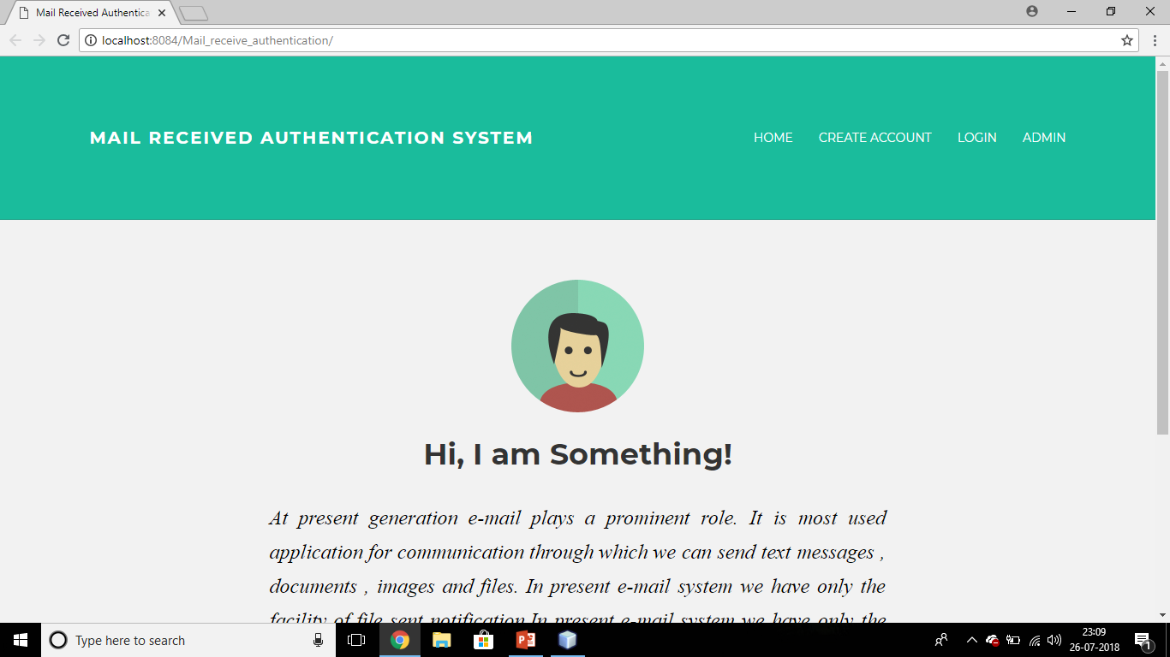

REGISTRATION PAGE

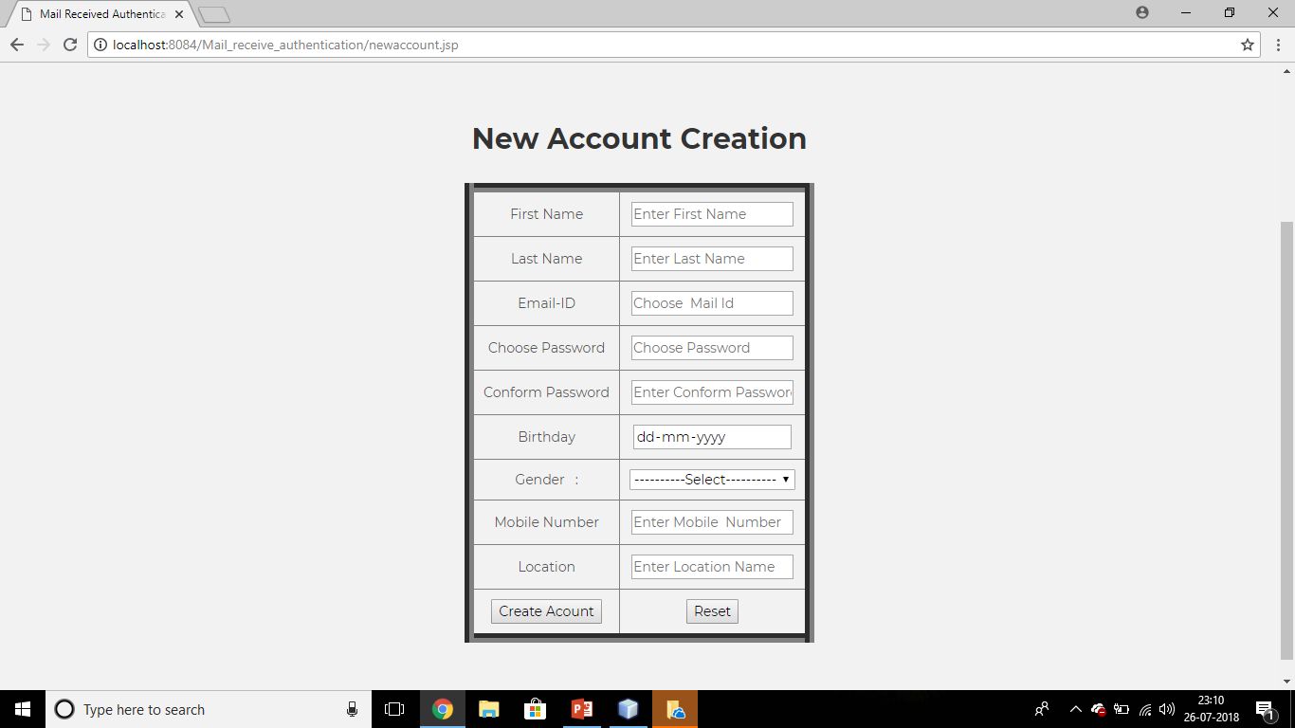

SUCCESSFUL PAGE

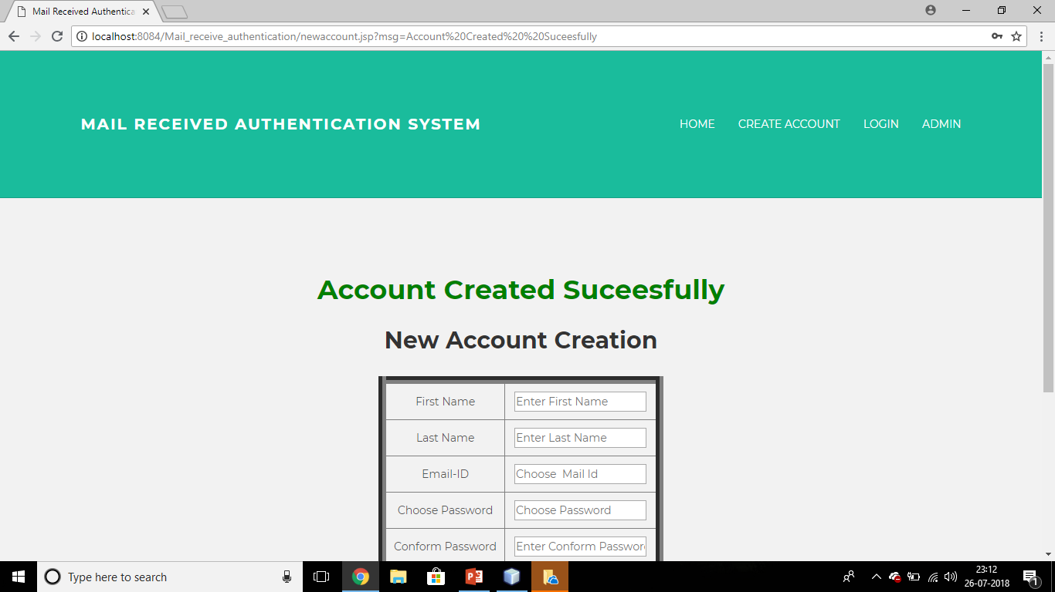

ACCOUNT LOGIN PAGE

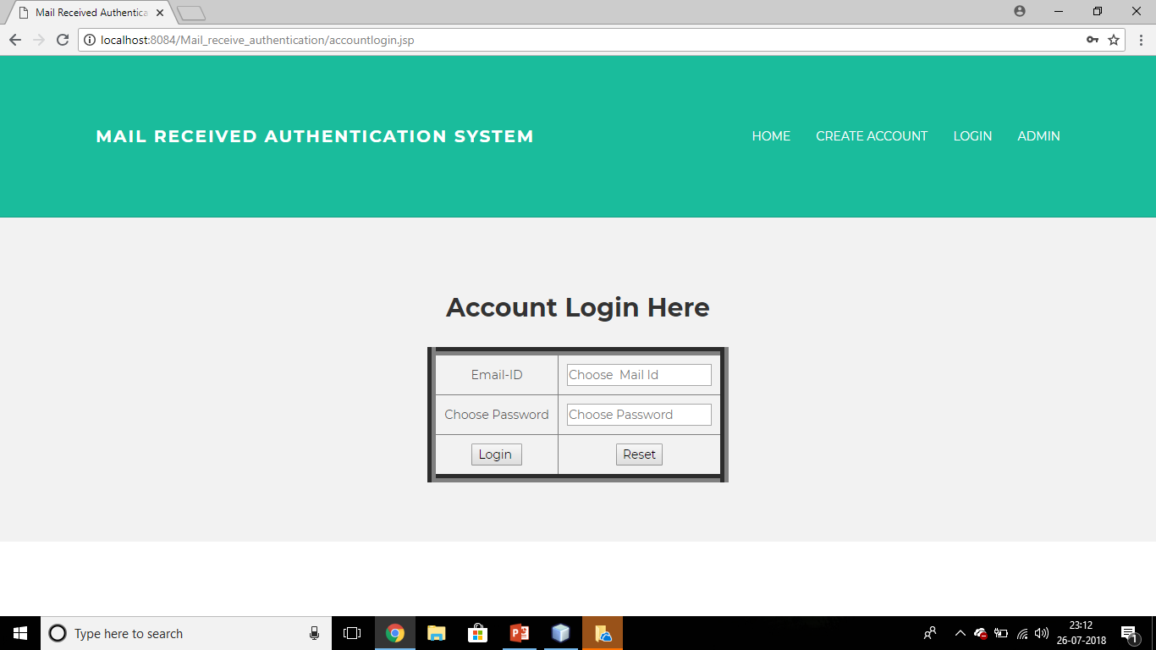

SENDER HOME PAGE

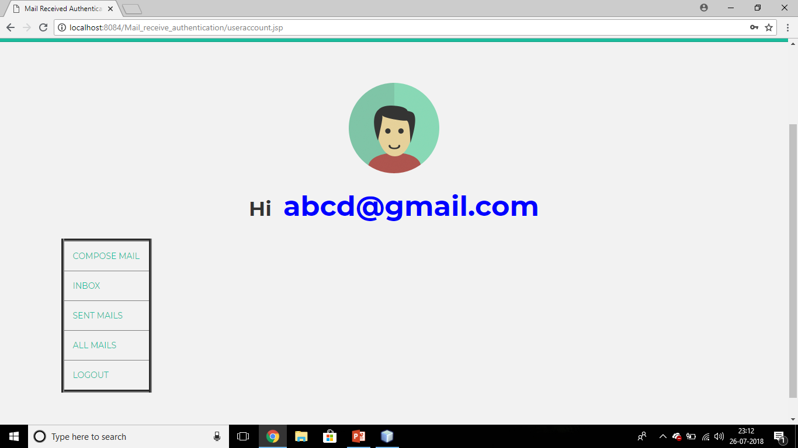

COMPOSE MAIL

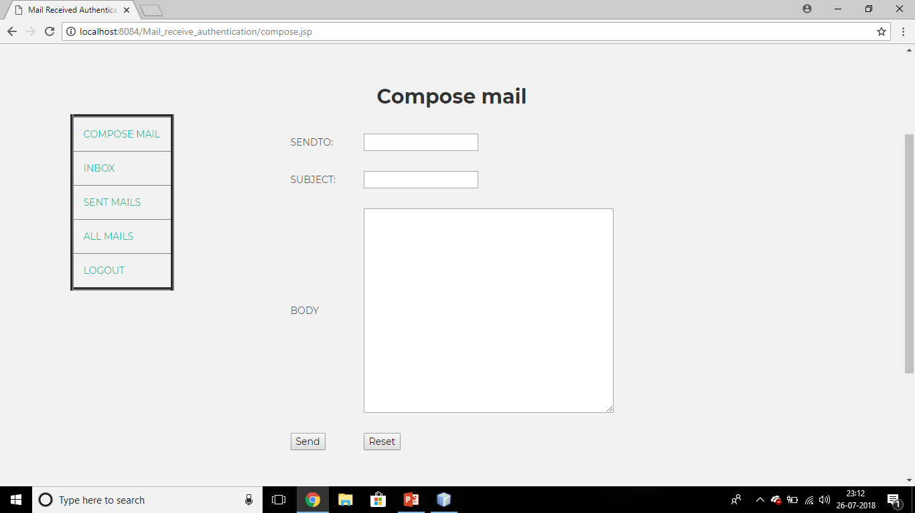

INBOX

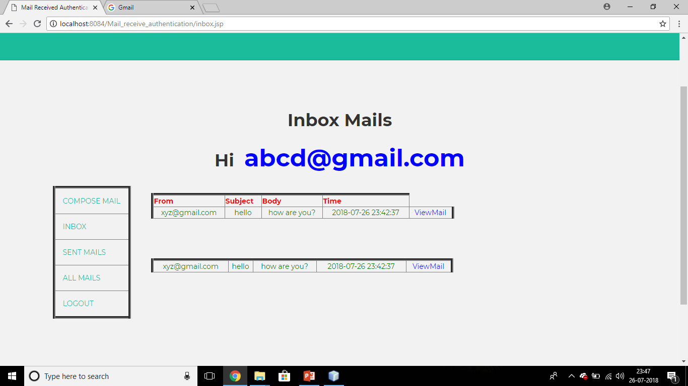

CHECKING MAILS

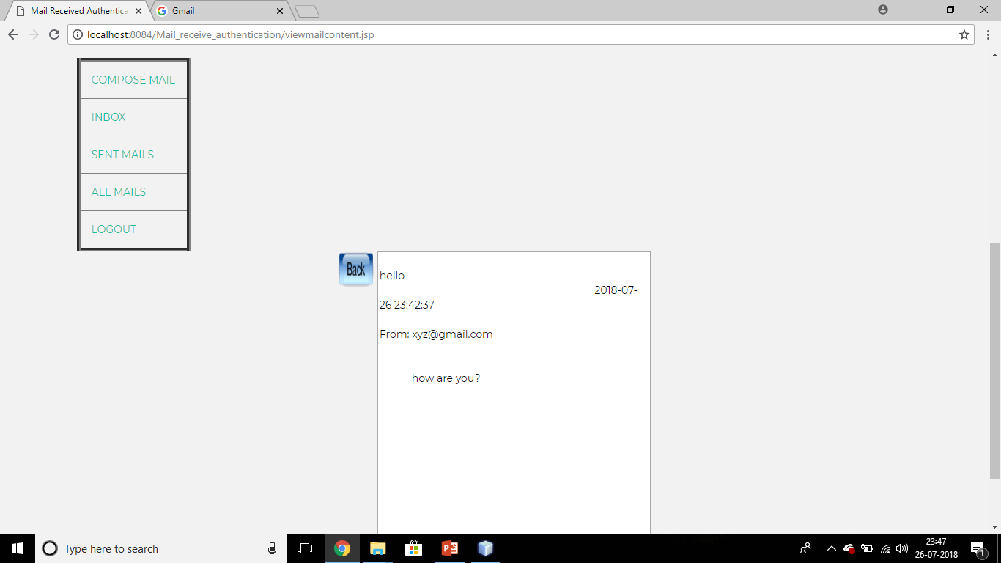

SENT MAILS

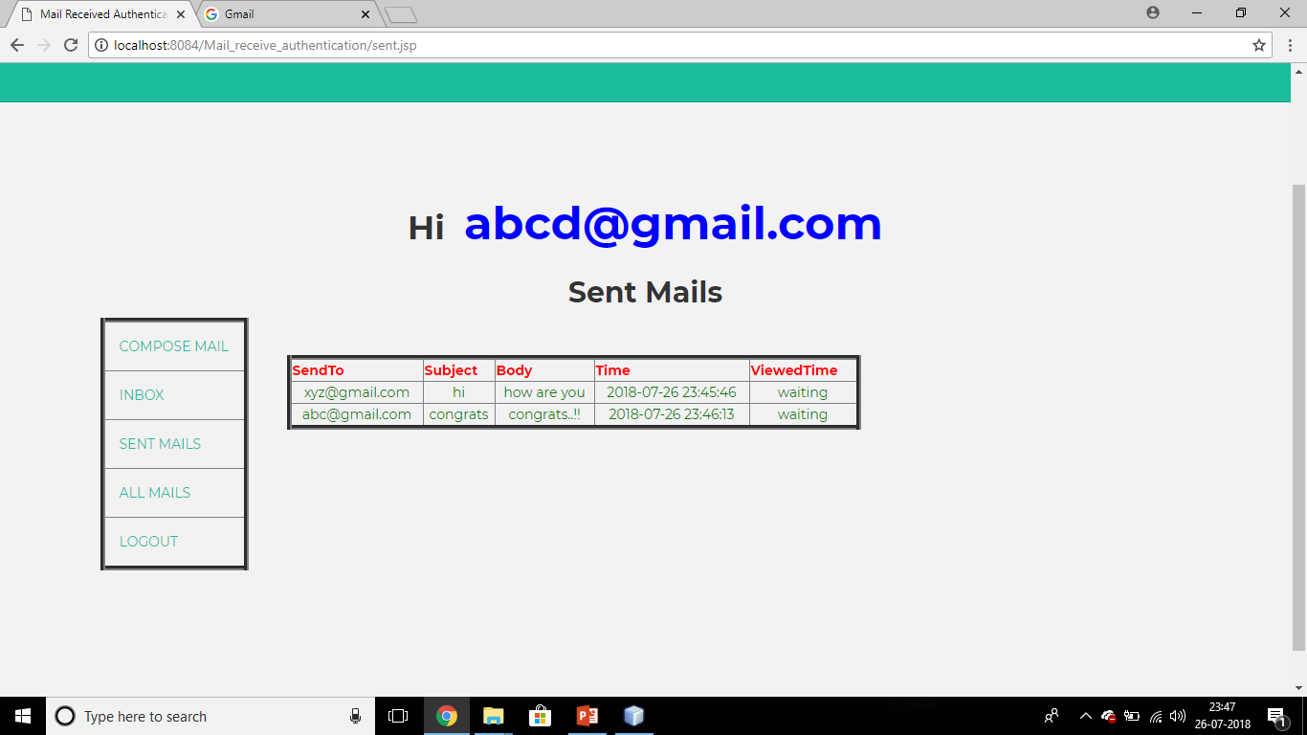

ALL MAILS

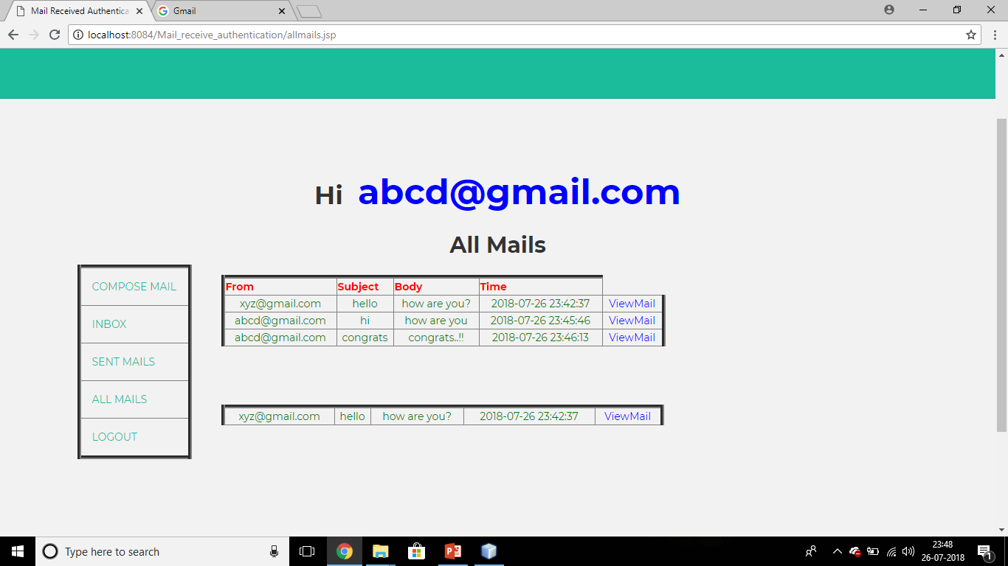

RECEIVER’S HOMEPAGE

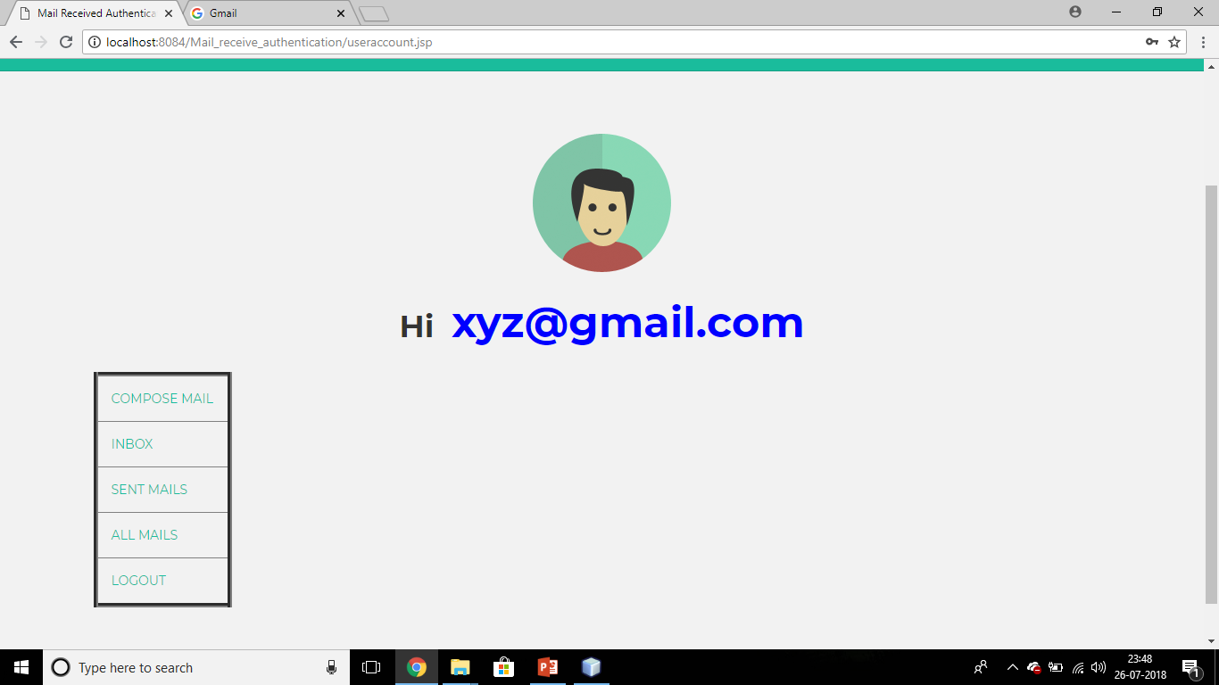

INBOX

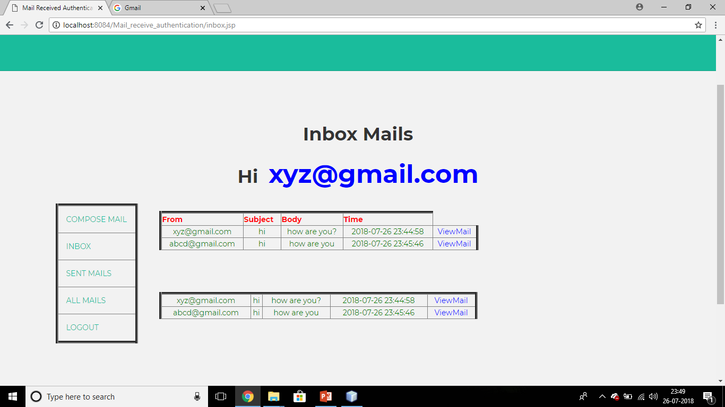

CHECKING MAIL

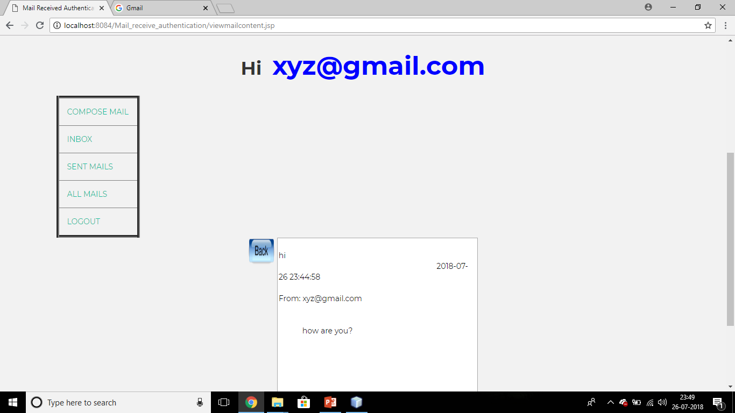

ACKNOWLEDGEMENT

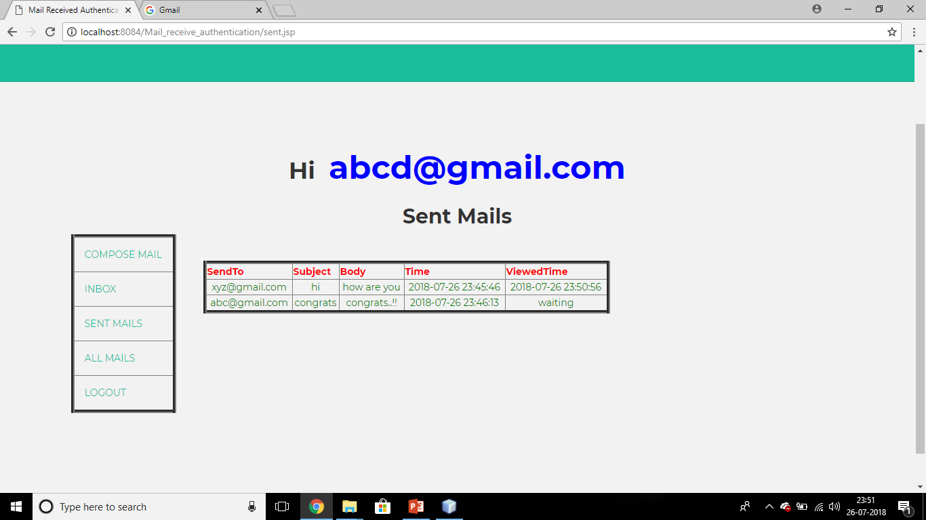

ADMIN LOGIN

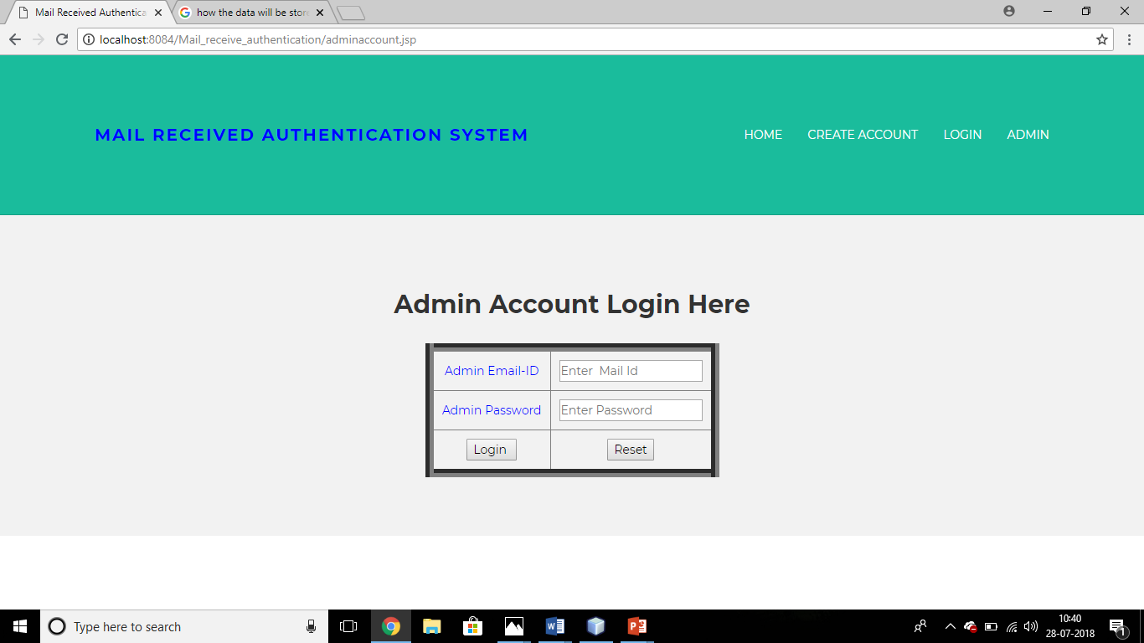

ADMIN HOMEPAGE

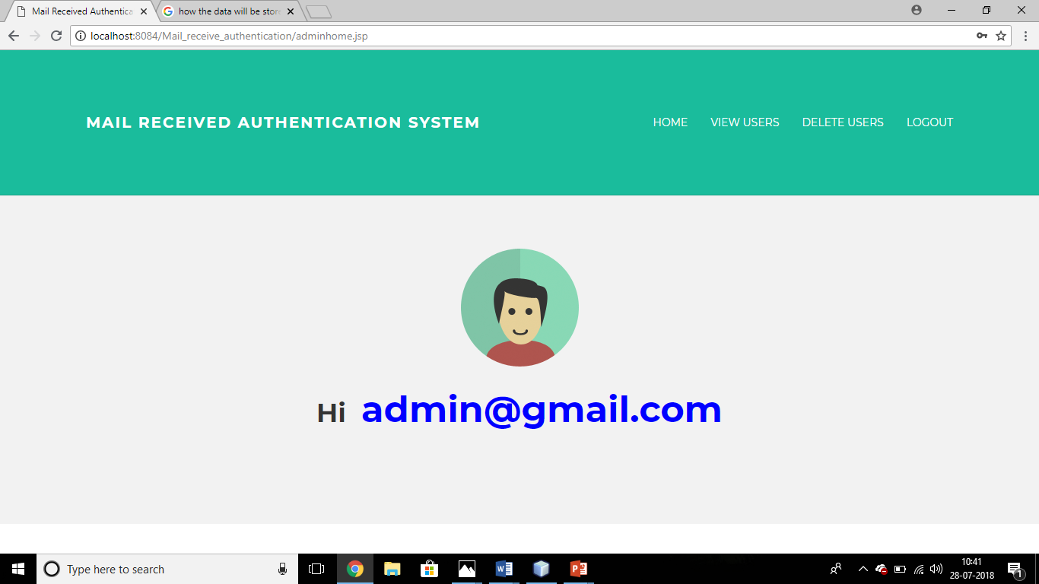

VIEW USERS PAGE

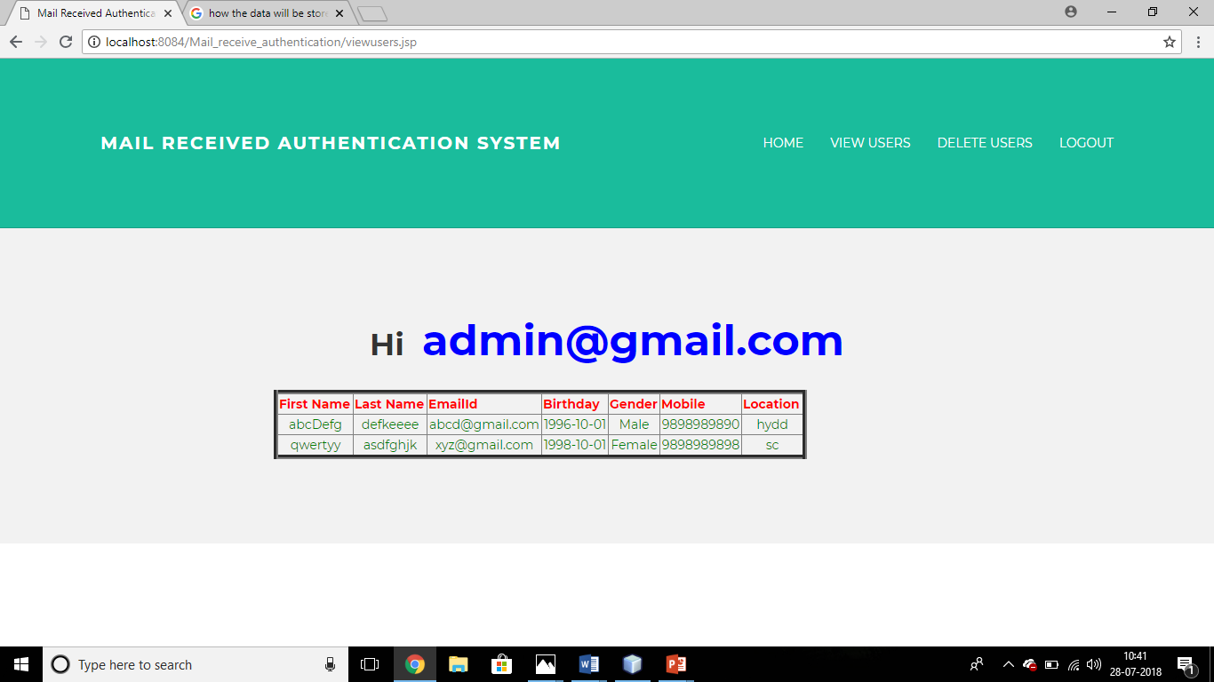

DELETE USERS PAGE

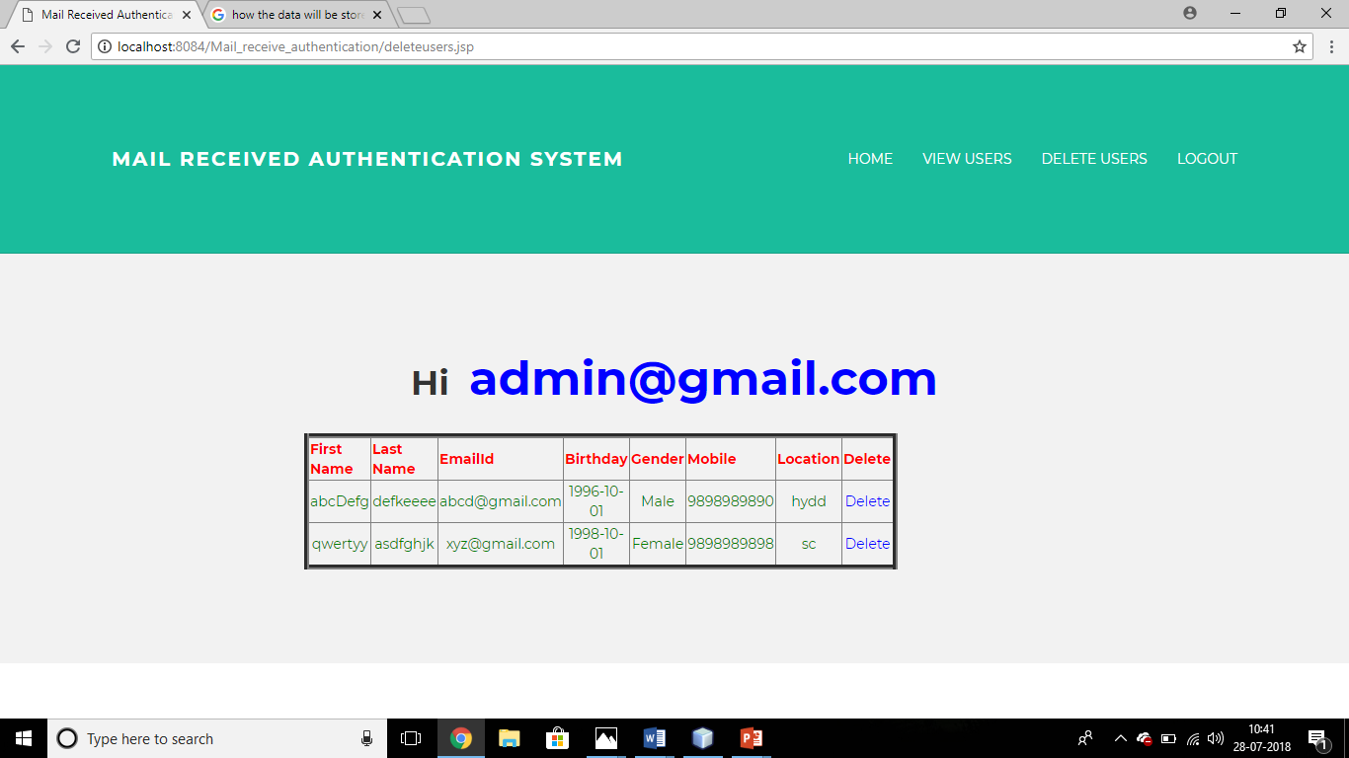

CHAPTER 8
CONCLUSION AND FUTURESCOPE

Conclusion
- By using this project sender is aware of the fact that his message has been read.
- This also displays the time and date when the receiver opens the mail.
Future Scope

Further modifications can be applied as of, change in the colour of notification head of the email as soon as the mail is read by the receiver

The sender can be made to receive a notification as soon as the receiver reads the mail.

BIBLIOGRAPHY

References for the Project Development Were Taken From the following Books and Web Sites.

JAVA Technologies
JAVA Complete Reference
Java Script Programming by Yehuda Shiran
Mastering JAVA Security
JAVA2 Networking by Pistoria
JAVA Security by Scotl oaks
Head First EJB Sierra Bates
J2EE Professional by Shadab siddiqui
JAVA server pages by Larne Pekowsley
JAVA Server pages by Nick Todd

HTML
HTML Black Book by Holzner

JDBC
Java Database Programming with JDBC by Patel moss.
Software Engineering by Roger Pressman

